**Creating Swap partition in Linux**

Linux uses swap space to deal with the shortage of physical memory. The swap space is the space of hard disk that can be used as the memory. The process of moving idle memory pages from RAM to swap is known as ***page out***. The process of moving required memory pages back from swap to RAM in known as ***page in***.

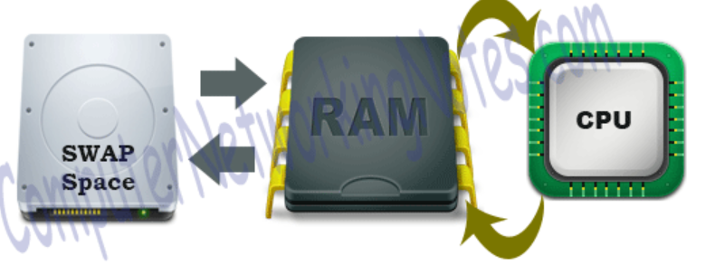

Check memory details

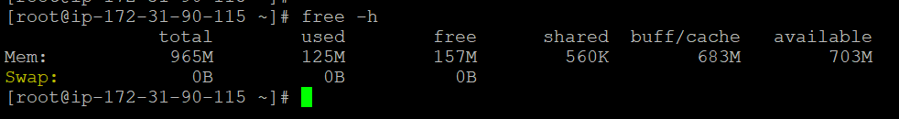

Check the disk info

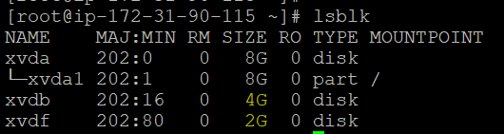

Create swap partition using fdisk

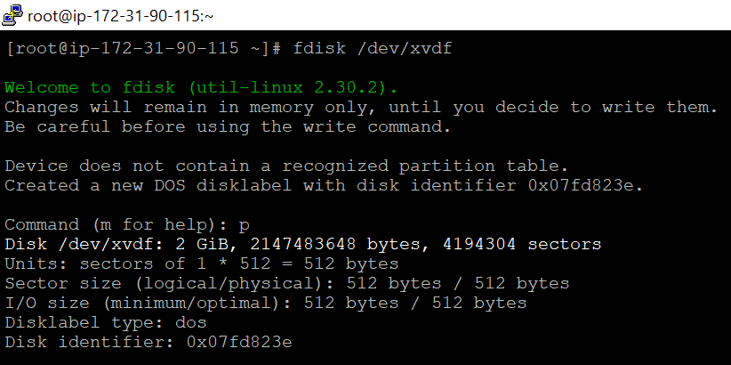

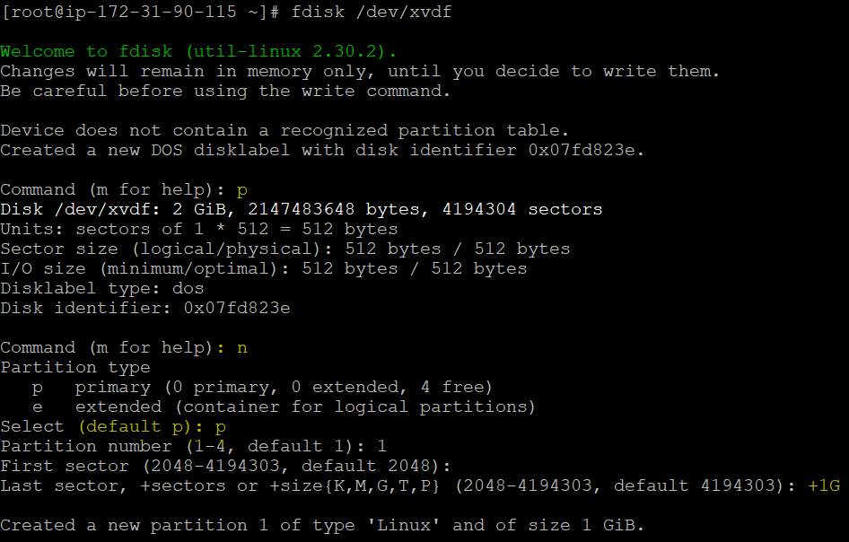

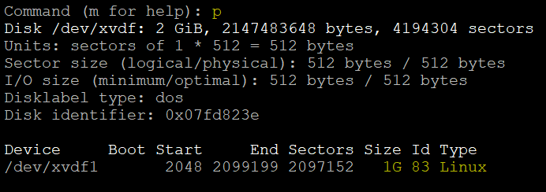

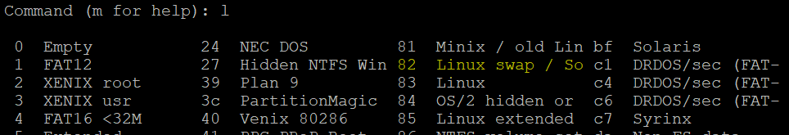

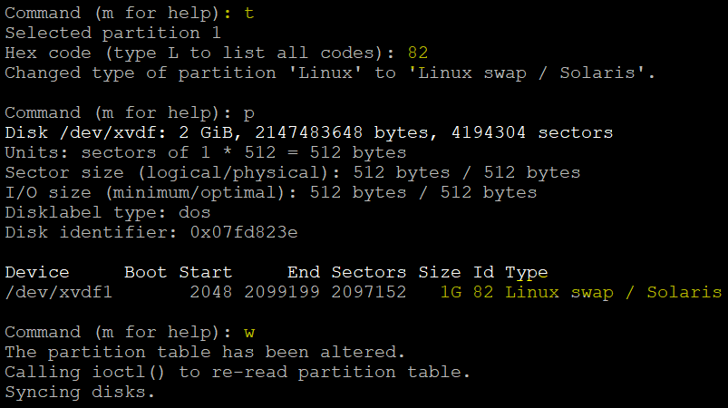

Run partprobe to make visibility to kernel



Make as swap partition

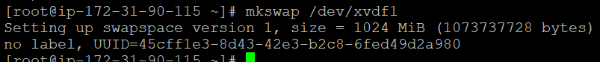



Get the uuid for swap partition device and mount in fstab entry



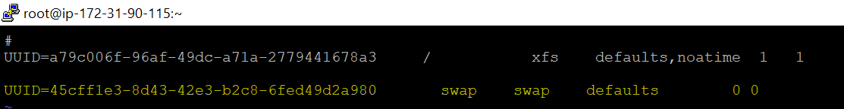

 Activate the swap partition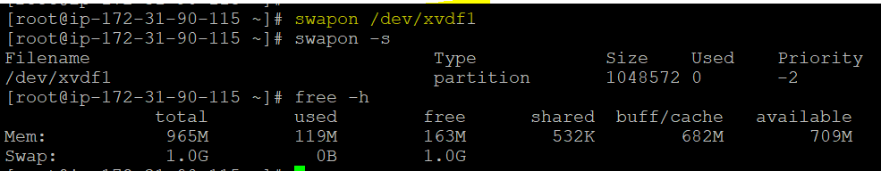

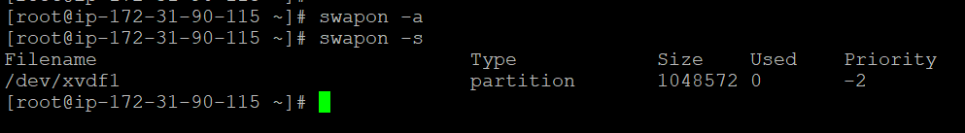

Verify the swap partition.

